Author
Solutions Engineering

Date Published
June 24th, 2020

Document Title
Subtitle
Document Title
Subtitle
Author
Solutions Engineering

Date Published
January 24th, 2018

Contents
Revision history 2
Assumptions 3
Blue Technology 3
SERVER UPDATES Blue Web Services 3
Dashboard Viewer Page 5
Requesting a Dashboard 5
Filtering the data 5
Contact us 10

Revision history

Version | Date | Modified by | Revision
0.1 | Month Day, Year | FN LN | First Draft
0.1 | Month Day, Year | FN LN | - Added X  - Added XX
0.3 | Month Day, Year | FN LN | Added X
0.4 | Month Day, Year | FN LN | Added X

Assumptions

Blue Technology
Explorance provides state-of-the-art hosted infrastructure. This infrastructure is leveraged by many esteemed organizations all over the globe.

SERVER UPDATES Blue Web Services
- Provides data from Blue Database
Provides data from Blue Database
- Blue Database 1
- Blue Database 2
- Blue Database 3
- Dashboard Configuration page
Pulls data from Blue Web Service
Allows Administrator to configure settings for Dashboard
Pushes Dashboard Settings to BI Web Services
- BI Web Services
Provides Dashboards Settings and data from BI Database
Accepts Dashboard Settings (new and edit)
Accepts User preferences
- BI Database
Stores Database settings and Database user preferences
(*who does the ETL data from Blue Database?)
Stores facts and dimensions obtained from the ETL.

Dashboard Viewer page
- Dashboard Viewer page
Pulls data from BI Web Services
Pushes User Preferences

SERVER UPDATES
- Dashboard Pages will be built as Browser Applications using the Ember.js framework

Dashboard Pages
- Dashboard Pages will be embedded in Blue aspx pages.
- Dashboard Pages will communicate with the web services through RESTful APIs
- Dashboard Pages will visualize data using the D3.js Data Visualization Library

Authentication
The data center in which the servers are located includes the latest standards in server rooms:
- Please see Authentication Document

The physical building is a bunker style construction with bulletproof windows, physical 24/7 security, video surveillance and building alarms. Access is controlled via biometric methods and a man trap entrance.

User Filters Dashboard Viewer (End-user) Access
- Through URL ($link variable): /dashboard/$DashboardID/
Inserted into any Blue task email.
Added as a link on Blue Dashboard page
Added as a link anywhere

Dashboard Viewer Page

Requesting a Dashboard
User is authenticated: Standard Blue authentication protocol applies as Dashboard is embedded in a Blue aspx page. For more details please read the Authentication Document.

Browser Application is loaded and requests Dashboard Settings for the given $DashboardID and User.

BI Web Services responds with Dashboard Settings Object, User Object and Notification Object (optional). Communication with BI Web Services is secured with a token. See Authentication Document.

Filtering the data
Dashboards show data for Subjects. Dashboard Filters limit which Subjects are included in the Dashboard. Some widgets show data for Tasks. These widgets show only data for tasks belonging to the Subjects included in the Dashboard. These widgets will handle their own internal task filtering.

User Filters
Explorance provides state-of-the-art SaaS hosted infrastructure. This infrastructure is leveraged by many esteemed organizations all over the globe.

- SQL Database - full SQL DB backup is performed daily to the backup server.
- Incremental backups are performed every 15 minutes.
- Application - A snapshot of the application conﬁguration ﬁles is per- formed.
- The Explorance hosted services are deployed on a physical server infrastructure
- Liebert® brand redundant cooling systems
- Liebert® brand redundant UPS and power distribution
- Redundant power generators that can provide 1.75 MW SQL Database - full SQL DB backup is performed daily to the backup server. Incremental backups are performed every 15 minutes.
- Application - A snapshot of the application conﬁguration ﬁles is per- formed.That is owned and operated by Explorance.

Quick Toggle Filters
The necessary measures are taken to ensure that the issue is properly resolved for the future.

NOTE
The Blue database transaction log should be truncated on a regular basis to prevent it from consuming all available disk space.
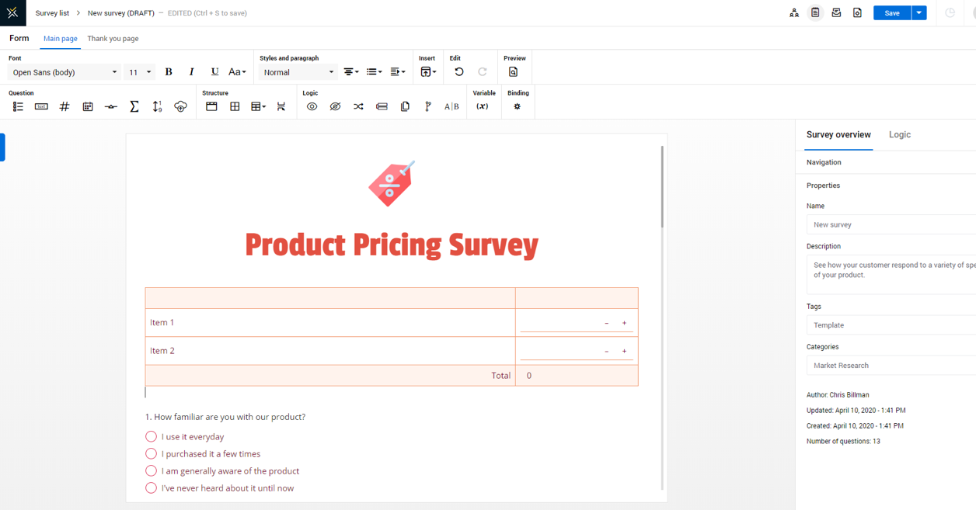
Figure 1. Template example

Active Filters are highlighted

Toggle filter

To delete a filter click on the X (Delete Filter Button). You will be prompted for confirmation of the action.

Multiple Filters can be active at the same time.
If no Data is available from the active filters then no Subjects will be shown. Widgets will display a "No data available" notification.

Widget Triggered Filters
Some widgets divide the included Subjects into groups. In these cases, the widget can activate a filter by selecting one of the groups. For example see Thresholds widget. Any widget acting as a filter will disregard its own filter so as to enable transitions internally by selecting another group. Each widget will continue to be refreshed by other widget driven filters.

Widgets

KPI Threshold
Splits subjects into groups based on time remaining for Subject evaluation and current response threshold for that Subject. For example, Subjects with less than 40% Response Rate and more than 30% or the evaluation period remaining.

Email Servers
Hover over a Group to see more details about the group.
Click a Group to select it and to filter the Subjects included in the Dashboard to include only members of the selected Group. The widget itself will not refresh and will continue to show the Subjects included in the Dashboard disregarding its own filter. Other Widgets will refresh to apply the widget driven filter.

Overall Task Status
Shows aggregate Task data for all included subjects in the Dashboard. Refreshes whenever filters change. Listens for all type of filter changes.
Hover over a group in the chart to see more details.

NOTE | HTLM CODE
#BlueSystemDefaultBody .left-menu-table .section-toggle {
background-color: #354052;
border: solid 3px #2a323f;
}

#BlueSystemDefaultBody .table-text,
#BlueSystemDefaultBody tr.GridItemStyle,
#BlueSystemDefaultBody tr.GridItemStyle a,
#BlueSystemDefaultBody tr.GridAlternatingStyle,
#BlueSystemDefaultBody tr.GridAlternatingStyle a {
color: #00417A;

For more example please consult the website:
www.explorance.com

Subject List
Lists all the Subjects included in the Dashboard. Listens to all filter types and all filter changes.

Select a Subject Demographic from the dropdown list to group the Subject in the widget by that Subject Demographic.

Click the columns button to open a multi select menu where you can toggle columns to show and hide.

Click through the pagination to navigate through the Subject list.
Click on a Subject checkbox to select the Subject. With no subjects selected, the response analysis widget will show data for all the subjects included in the dashboard.

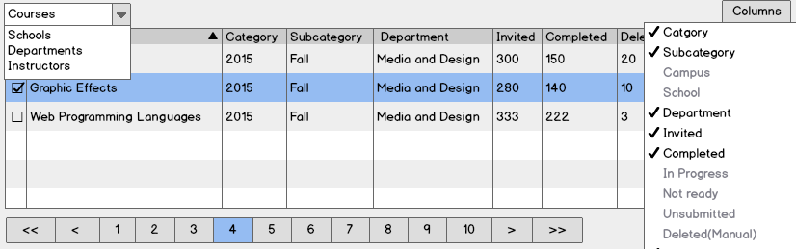

Figure 1. Table selection

PHYSICAL ACCESS
Displays Task Data for the Subjects included in the widget.

The widget has three modes:
- Aggregate: Default mode, always available.
- Comparison: Available for a maximum of 5 subjects.
- Historical: N/A (*stage 1: available for single selection item.)

Timeseries chart
- Displays dates on the X axis.
- Display Volume/Rate on the Y axis.
Inserted into any Blue task email.
Added as a link on Blue Dashboard page
- Added as a link on Blue Dashboard page

Bar chart
- Displays days of the week on the X axis.

“If Subjects are selected in the Subject list widget, they will be displayed here. Subjects displayed here can be toggled on/off and can be removed as selections from the Subject list widget. It’s important to not hesitate”
Dr. Justin Taylor, Chief Customer Officer at Explorance

Contact us

Contact | Email
Sales | sales@explorance.com
Support | sales@explorance.com
Business Development | partners@explorance.com
Media & PR | marketing@explorance.com
Webmaster | webmaster @explorance.com
General | info@explorance.com

Source: Blue Notes
Source: Blue Notes 2

